**Calculate the Square Root of a Number**

1. approximate root

* Add the approximate root with the original number divided by the approximate root and divide by 2. 🡪 { x_i := (x_i + n / x_i) / 2 }
* Continue until the difference in the approximate root along the iterations is less than the desired value (or precision value).

Example :

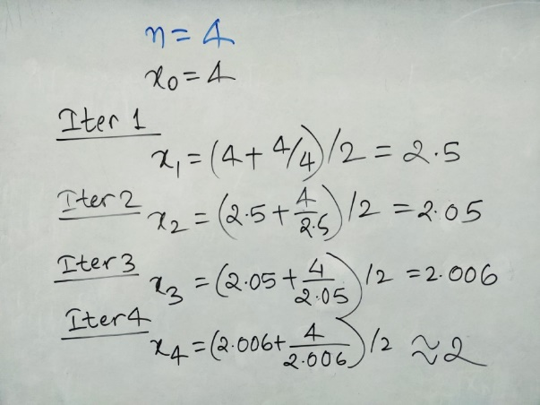

1. Prime Factorization

This is the simple way of extracting square roots. Herein, we carry out prime factorization of the given number and then group the factors in pairs of two. We then multiply the numbers from each group to arrive at the square root. The rationale behind the procedure is self-explanatory.

For example

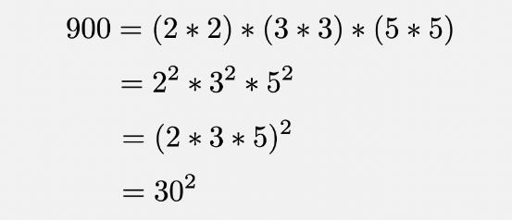

# Approximation with Binary Search (Any Root)

1. **Start with an initial guess**. For this algorithm, we will choose half of the number.
2. **Adjust the value**. If the guess squared is smaller, make bigger the value in a step of 1/2^index. If the guess squared is bigger, make smaller the value in the same quantity.
3. **Repeat step 2,**until you have the desired precision.

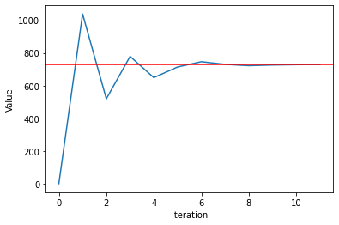

# Taylor Series (Square Root)

# the most satisfying and complex of the methods shown. It all comes down to this formula:

# 

Which use some very interesting properties of the binomial coefficients. One important thing to note is that the formula above only converges if the absolute value of x is less than or equal to 1. That means we cannot put any value of x.

Nevertheless, we can use a simple trick:

1. **Transform the number into a decimal one**. For instance, we divide it into a power of 10 (like in scientific notation) to obtain it into a decimal and then subtract one from it.
2. **Apply the formula above**. In this case, we will sum 10 terms.
3. **Undo the transformation.**This will give us the result.

To achieve this, we will have to create a binomial coefficient function and a factorial one.

# Logarithmic Properties (Any Root)

We can convert our problems into other ones which we know how to do them. In this case, there are quick ways to obtain the exponent function and the natural logarithm. We just add a division in the process… and the square root is obtained!

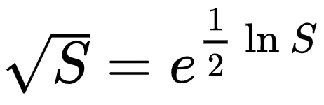

1. Calculate ln(S) with a quick convergence sum, and divide by 2.
2. Raise e to the number, using the Taylor Series for e^x.

